- What organization have you chosen?
I have chosen Alley Cat Allies which is a nonprofit organization focused on helping out cats.
- What is the organization's main goal or goals? (e.g., sell razors, build resources to support homeless veterans, etc.) Does the organization have a mission and/or values statement? If so, copy and paste it here.
Alley Cat Allies’ main goal is to advocate for the wellbeing for cats all over the world by advocating acting and donating to the organization. Their mission statement is “to transform and develop communities to protect and improve the lives of cats.”
- Who is the organization's target audience(s)? Any secondary audiences? How do you know this? That is, what evidence helps you identify the target audiences? Do any audiences seem to be missing?
I believe the target audience is cat lovers with an emphasis on people who take care of cats. They mostly had photos of cats with 70% of the posts that had a cat. They had a variety of different types of cats pictured with all of different colors and types. If you look closer to the posts they have information (especially on Facebook and Twitter) about how to take care of cats. This is usually linked to their website and a relevant page about cats. If you look at the caption for the photo it is usually asking the viewer what they like about cats. This is targeting people who care about cats.
They secondary audiences are veterinarians and shelter workers. They have multiple infographics that demonstrate how to treat feral cats ethically. There infographics do not explain in everyday terms about the topic. They use medical terms to explain the spaying process instead of explaining it. They also have information about neutering and also has specific pages on their website for animal shelters and vets.
They are missing a lot of audiences especially related to younger people. Most of the people who interact with this organization are on Facebook (which is mostly full of older people). They are usually talking about their own cats. I am sure there are teenagers that want to help cats out. They also do not interact with any other animal organizations. They could reach out to animal lovers and advocates instead of just the cat owners. They also could reach out to cat bloggers to create a new way to showcase how to help out cats.
- What social media platforms is the organization in? Which ones is it most active on?
They have Twitter, Facebook, YouTube and an Instagram account. They are most active on their Facebook and Twitter.
- For each social platform, answer the basics and include where appropriate your data from the Coding Analysis you did:
  - What is their address/handle for their channel/site/username in the platform?
There Twitter handle is @alleycatallies.
Their Facebook handle is @AlleyCatAllies.
Their Instagram handle is @alleycatallies.
Their YouTube channel is titled AlleyCatAllies.
  - How long have they been on that platform? are they still active?
They are active on all their platforms, but some platforms update more than others. They joined YouTube on September 7th in 2007. They joined Twitter in October 2008. They joined Facebook in May of 2009. Their first post on Instagram is in September 2013.
  - How many posts/tweets/video uploads do they make per week or per month?
They post a video 10 times a year on YouTube. They post roughly 3 times a week on Instagram. They tweet roughly 9 times a week with occasionally they retweet other creators but that is only recently. They posted roughly 9 posts a week on Facebook and one video every couple of months.
  - How many followers do they have?
They have 2.56 thousand subscribers to their YouTube channel. They have 19.6 k followers on Instagram. They have 31.1 k followers on Twitter. They have 476,824 followers on Facebook. This could be because only their Facebook account is verified.
  - Looking at recent posts, who seems to be the target audience(s)?
The Facebook and Twitter posts are almost always the same, so they likely have the same target audience. I believe that they are trying to connect to people who want to help cats out. They use words like “advocate” and “donate”. This gives people easy actions that they can do to help out cats. They are trying to connect to people who are unsure how to help out but know they want to. They mostly have posts on what you can do to help out cats and access to information to educate yourself.
Instagram has a very different target audience. They focus on posting cute cat photos. This means that their target audience is likely people who like cats and want to see cute cat photos. The captions are usually short and have a hashtag attached to them. They are not talking about what the viewer could do which is what the other platforms are doing. They are just trying to get people to engage with their posts.
  - What are the types of content they are posting? Categorize it. Be very specific and tailored to your organization--e.g., fundraising, contests, showcasing new products, celebrity endorsements, posts soliciting user-generated content, etc. etc.
There Instagram content is mostly focused on cute cat photos. This occasionally has ways to engage with the post, but it is mostly short captions. The content is based on aesthetics instead of education. They are trying to get people to look at the photos. They occasionally include educational posts. They are trying to get people to help out cats. They give short snippets on how to take care of cats.
Facebook and Twitter mostly focus on getting people to donate to the organization, connect to their website, and spreading education. This includes advertisements of the things you get if you donate. This includes occasional merch. These platforms also have the photos that are on Instagram (this is analyzed above). Almost all of the posts have a link to a relevant page on their website. This is a way to get people to look at their website. These posts usually link to relevant articles for the person to learn more about the post. This is usually showing one fact and then promising more on the website. These are the only types of content that Alley Cat Allies uses.
  - What types of content seem to gain the most engagement (e.g., shares, likes, retweets, comments)? What platform and rhetorical strategies are used to increase circulation (e.g., hashtags, use of take-overs, etc.
All of the platforms use the same hashtags to increase circulation. This only really plays a factor on Instagram. They also use links to their website to help increase circulation. Other than that, they don’t have much strategy for increasing circulation.
On Facebook, they get the most engagement on community-based content. Most of the posts invite people to comment but gets most engagement when people talk about themselves. If they invite ways, people will talk about their cats or their experience working with cats. This causes the most comments because people want to talk about themselves.
On Twitter, they get the most engagement on activity-based content. This could be reading an infographic, connecting to an interesting post on their website, or answering an informative question. They do not get many comments on any of their posts.
On Instagram, they get the most likes on #FeralTuesday cat posts. These posts get over 300 likes compared to most of their other posts get 200 likes. They get the most comments on content that acts such as helping out cats impacted by Hurricane Ida. These are the only posts that seem to get comments consistently. The #Caturday and #FeralTuesday posts occasionally get some emojis, but it is not consistent.
  - Does it appear that the organization is using paid or organic content?
I believe that Alley Cats Allies only uses organic content. Since it is a nonprofit, I do not believe that they would use the money for advertisement purposes. They talk about having the donations going to cats. I think this would go against their brand if they did paid content on any of their platforms.
  - For each platform, please analyze how well the channel does at representing diversity, equity, and inclusion of diverse peoples (based on ability/disability, race, ethnicity, gender, country of origin, sexual orientation, etc.)
All of their platforms do not do anything to represent diversity, equity and inclusion of diverse peoples. There are very few posts of men, and I can not find a photo of BIPIC individuals. They are not using their spere of influence to show how their organization includes these people. The organization tends to keep their stances on political things silent and they are only political thing that I can find is on their website (this is a blog post titled “Defund the Cats”). The only diversity that they represent is the variety of cats. Even with the amount of diversity of cats there are not many photos of overweight or injured cats. They are not inclusion in their posts. They do not have captions for the photos, there is no video descriptions, and the infographics have problems for readability. The infographics have small font and use both red and green. The posts themselves vary on the text inclusiveness because of the length. Some of them are very short while others are very wordy. It would not be a good either way for screen readers.
  - In what ways does the organization seek to engage with contemporary social discussions? if they don't seem to, are there ways and places that perhaps they could?
They avoid engaging with contemporary social discussions.
They use YouTube to talk about relevant social discussions about cats. It is not very frequent so most of the time it feels out of place. They would need to have more frequent and relevant posts to really engage with the discussion.
I do not think they should do much contemporary social discussions on Instagram. They could have links to relevant websites (besides their own), and it could have something in the caption. They mostly do cute cat photos on this platform, and it works. They could highlight certain members on their Instagram Stories who are apart of relevant social discussions.
On Facebook, they could use Facebook Video to engage with social discussions. This would be the way to spread their message and be more personal. On Facebook, their current content is working really well so I would not recommend changing it that much. Their Facebook Videos have been going very well and if they did that more it would be more effective.
I think they could use their platform to promote contemporary social discussions on Twitter. Twitter is the place where most contemporary social discussions happen. I think this would be the account they could use to talk about the BIPOC in their organization. They have links to relevant articles for cats so it would not be that different.
  - Specific analysis of posts in the channel: pick 2-3 posts from each platform and screengrab the content and insert in your notes. Analyze the example in depth (about two paragraphs for each post) in terms of rhetoric (audience, purpose, context) and in terms of design. Reflect on what strategies (e.g., stories, frames, rhetorical appeals, etc.) are used to encourage the audience to change their thinking or behavior? Be sure to discuss how the modalities in the post (text, images, audio-video etc.) work together (or not) to convey the post's message. And discuss whether you think the post is effective and how it might be made more so.
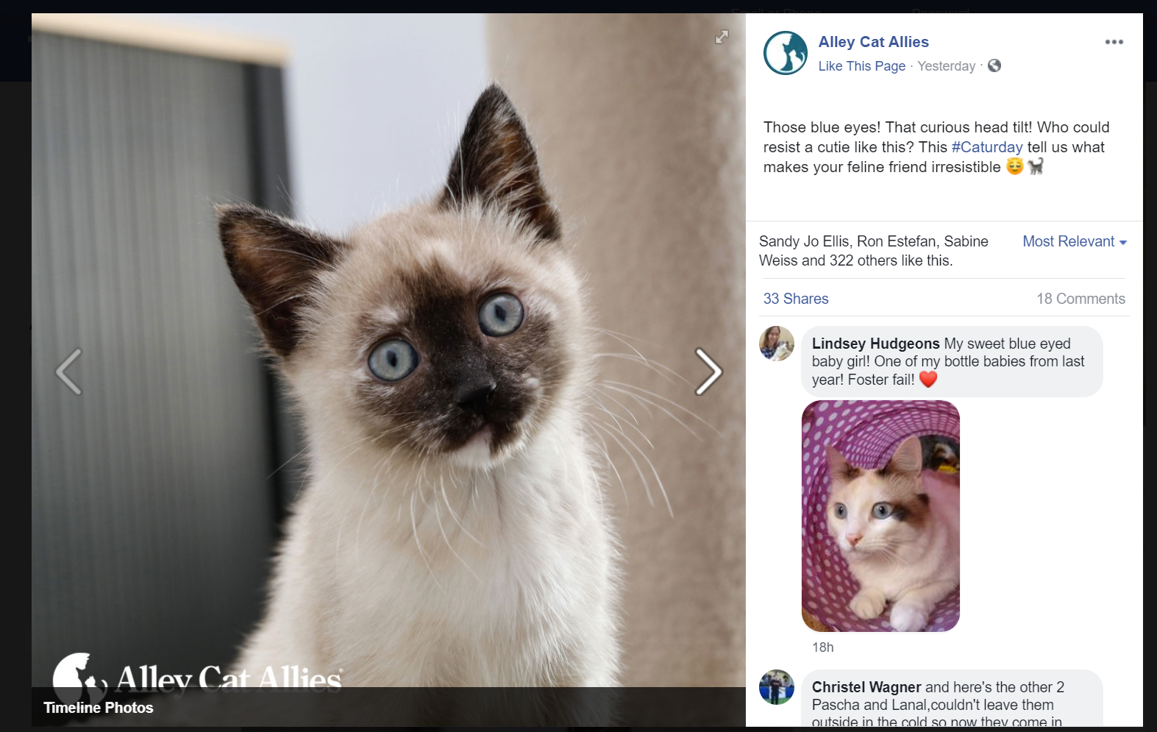
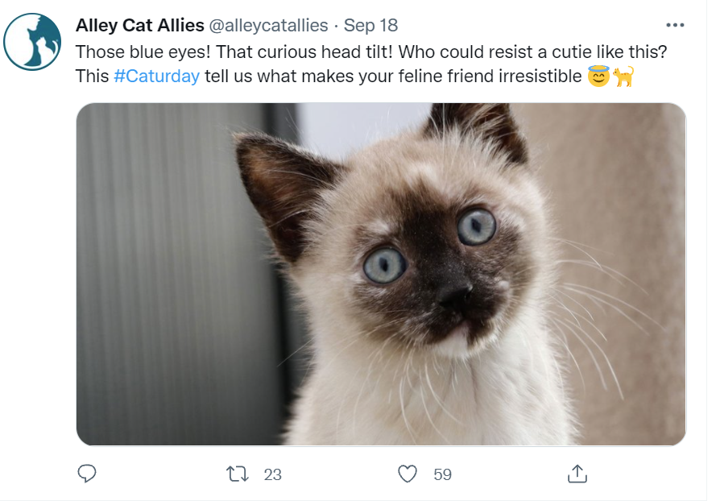
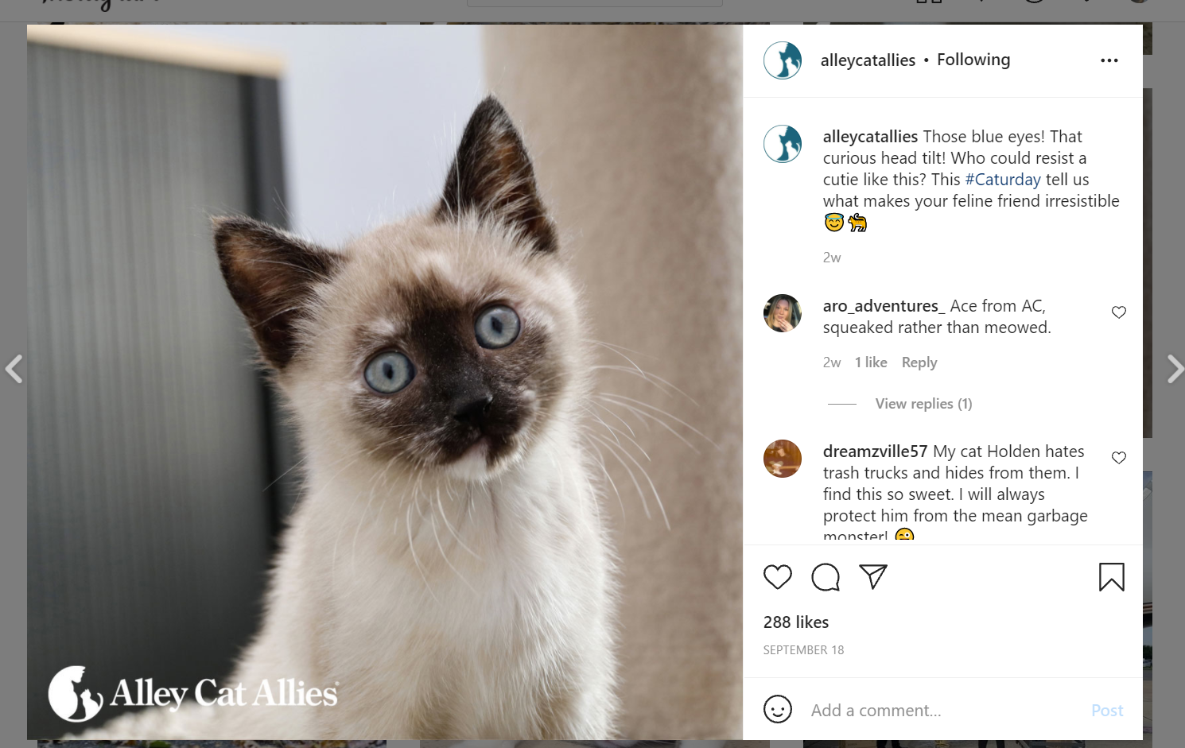
This post is on Twitter, Facebook, and Instagram. The audience for this post is cat lovers. They use the caption to get the audience to interact with the post and tell why their cat is adorable. They have the cat in the front with the background a little blurry. The post has balance because the cat is not centered which helps balance the tilt. The purpose of the post is to engage with the post and create continuity with the #Caturday. They use this post every Saturday and this creates a schedule for the audience to follow. The context of the post is that it is Saturday, and they post weekly cute cat photos then. They mostly rely on pathos for this post. They are not educating people about cats instead they are talking about why they love cats. The photo itself has the cat titling its head which is very cute. They are trying to make non cat lovers like cats with this post. This is a way for them to see the post, feel a connection, and then want to engage with the organization.
This post has two modalities which are the picture and the caption. Instagram uses the caption to tell what is going on and is an afterthought after looking at the photo. I do not think that the caption is the best way to engage with Twitter and Facebook. The cropping is weird for the Twitter photo. This makes it difficult to see the head tilt that they are talking about in the tweet. They also do not use close to the number of characters for the tweet. I feel that there is more to say and that could be why no one commented on this post unlike the other platforms. I feel that they should have put show us what makes your cat special. As you can see from the screengrab, people are commenting photos of their cats. I feel that if it was reworded a little more personally from the owner of the cat more people would connect with it. If the owner/fosterer would say something like “Cutie may look cute on the outside, but she is an amazing cuddler as well. I am so glad that I took her in, and I think she is glad as well.” This would make it more personal than the kitten looks cute. I think that adds a narrative to the post which would cause more people to want to share their story.
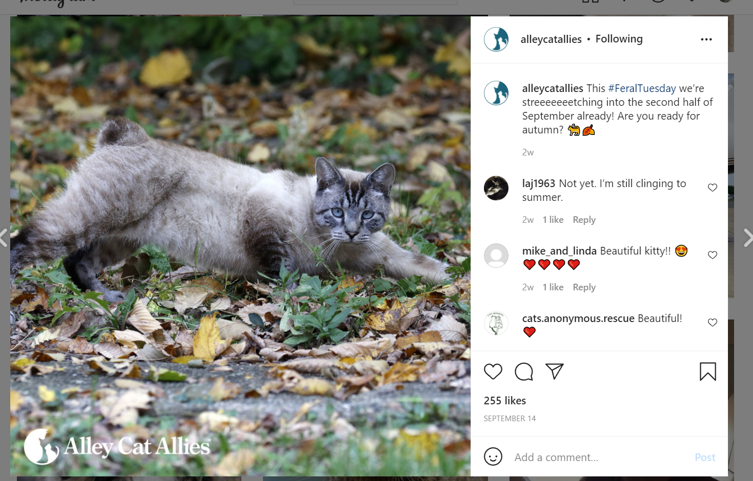
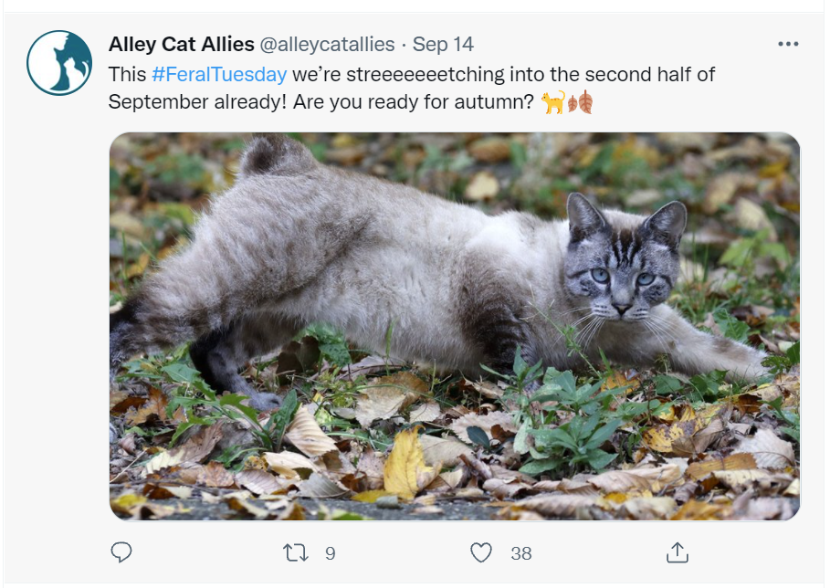
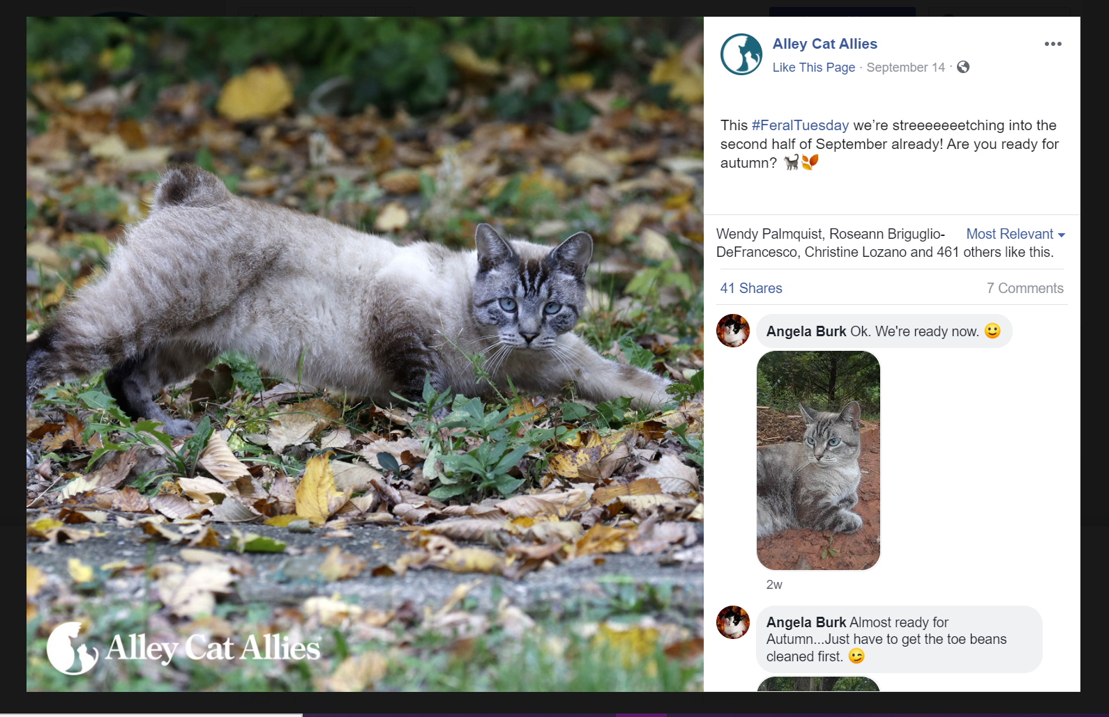
The audience for this post is cat lovers with the purpose is to engage with the organization. They use the hashtag #FeralTuesday to create continuity between all of their Tuesday posts. The context is to show that feral cats are still cute cats that can be loved. They have a cat in the center of the photo with the outside out of focus. They have the logo in the left corner to create balance with the outstretched leg. I do not think that they use any filters on the photo and the only editing is the blur. They focus on using pathos to get people connected. People like cute animal photos. They are not talking about how to help cats. They are just showing how great cats can be. They also appeal to the people who are excited for fall. This post talks about how people are excited for fall. This creates a sense of community with the people who see the post. They are trying to get people to think about how the season is changing. People who see this post think about how this will impact their lives and their cats.
The photo and the caption work together to convey a message. I am not sure that this message is one that the organization wants to demonstrate. This is something that most accounts talk about. The message is nothing special and the way it is presented is nothing new. This post is very good for Instagram because it has the focus on the photo. The photo is well balanced and has a focus on the cat. I think this would be more effective if it was a gif. Imagine a cat stretching out. This would be a way to convey their message more uniquely and then connect it to their organization. The caption as well needs some more improvement. It does not tell anything about the organization. If they had a cat fact about how many cats are kicked out of their homes during fall or how many muscles are in a cats arm this would fit the brand. This post as well has a weird zoom for the Twitter photo. It makes it hard to see their point. I think all of the platforms would benefit for a better caption with more information and a more active photo. This would make it more eye catching and spread their message better.
  - Overall analysis of the channel: what primary modalities (e.g., image, text, video, etc.) does the organization use in their posts? Are there modalities they rely on too much? Any they are missing that might improve engagement?
Facebook and Twitter focus on images with text. They rely on this modality too much. Sometimes the text includes links which is good with engagement. There are occasionally videos, but they need to do more to improve engagement. Both platforms could use some more posts that include infographics. These posts seem to go really well on Twitter. Facebook should use more Facebook Video to help improve their engagement.
Instagram almost always uses cat photos with short captions. Occasionally they have more information in the captions. I would assume that they rely to much on photos because that is mostly what they use. I think that they can use more cat videos. I also think that they could have some more posts that focus on
Their primary modalities are images with captions. They mostly rely on cute cat photos, and it leans towards the too much side. If they are all about education they need to include more infographics. They need to figure out what they want their social media will talk about their organization. If they want to be a cat lover organization they should focus on ways to show cats being cute. If they want to be an organization that is for cat families they should have more information on how to interact with cats. If they want to be an advocacy organization they should post more about the policies.

  - Overall analysis of the channel: what are the strengths of the organization's use of this social channel? (Remember in your answer to think too of the particular affordances of each social platform and whether the organization is leveraging opportunities.)
They are really using Facebook to its advantages. They are hitting their target audience of older individuals who have money and time to help out. Most of the posts I analyzed had at least 300 likes and at least one person commented on it. They are getting people to engage with the platform.
Instagram they are using the visual aspect to its advantage. All of the recent posts are aesthetically pleasing with the cats in the focus. They are using photos to show that they are focusing on cats. They also are utilizing hashtags to help show their posting schedule. You know they are going to post on Tuesday and Saturday. The person expects a cute cat photo. Their Instagram is full of cute cat photos.
They are using Twitters passion to act to connect people with their website. Most of their posts have a link to a relevant article if people want more information. This increases their ethical appeal because they are spreading education. They also use Twitter to mostly rely on what they are saying and not the photo. There is more emphasis on the tweet because that is the main focus scrolling through Twitter. This is causing more people to see their message instead of focusing on the pictures.
  - Overall analysis of the channel: what are the weaknesses of the organization's use of this social channel?
The largest weakness of the organization is not focusing on what works for each platform.
On Facebook, they are doing pretty well but there is still room for improvement. Facebook is a combination of video and photos. They are focusing on the photo aspect of this, but their videos do very well. They get tens of thousands of views, and this is a way to directly talk to the viewers. They need to utilize Facebook Video more because that would improve their social channel.
On Instagram, they are really struggling with standing out in the crowd. Posting cat photos is nothing new on the internet and having cat photos with cute captions is not revolutionary. They need something to make them stand out more as a reputable source of information and advocacy. Right now, their posts look like every other cat lover Instagram channel. They should instead focus on what they can do for the viewer instead of just being another source of cat photos.
The biggest weakness for their Twitter is that they are trying to hard to make it their Facebook. As we learned in class they are totally different platforms with different audiences. The posts that work well on Facebook work poorly on Twitter and vise versa. They need to lean away from the cat lover audience which is not a large majority on Twitter. They need to focus their audience on advocacy. They have to large of an idea on what type of content they want to post on Twitter. They need to narrow it down to help create continuity and community.
- Reflecting across all the channels you analyzed, how would you describe this organization's/brand's content strategy? For example, Taco Bell's wants to be a friend and posts across all platforms aiming to be a interesting, engaged helpful friend for young adults aged 15-25. Related to this, does the organization have a cohesive strategy across its channels? In terms of both design and content? If so, what is it, and how could it be better? And, if not, what could or should it be?
Alley Cat Allies wants to encourage cat lovers around 35-45 to donate to their cause and interact with their website. They post on most platforms with a very similar message across all of them. Their strategy it too cohesive and it needs to be different. Their profiles, posts, and even captions are almost identical. The only real different is how the emojis and post is presented on the platform. They should create different platform organization and it would be beneficial if there were different people for platform. It would help create a different voice per platform. They need to have one continued point of their organization which could be a logo on each of their posts. They vary on if they have the logo and where it is located. If they had a plan where to put it that would be beneficial.
Another big thing is trying to get verification on Instagram and Twitter. This would be a way to get more people interacting with their organization and make them more reputable. They also need to do something about adding more people shown on their social media. There is more than one person running this company. This will show that this organization encourages diversity. People want their organizations especially their nonprofits to encourage that. They also could include more diversity in the cats they show. All of the cats are well groomed and not injured. This would be a way to show that the organization supports all cats even the ones that come from bad situations.
I think that each platform should focus on what types of posts are successful (have a lot of interaction) on each platform. Facebook should be similar because they are significantly more successful than the other platforms. They should increase their Facebook Video posts. These posts get a lot of traffic (in the thousands of views). This would be a way to communicate with the people interacting with the organization. This is taking away the middleman of sending them to the blog posts on the website.
Instagram is a very visual platform, and they are getting a decent amount (roughly 200 likes) on their cat photos. I would recommend adding some variety of posts to make it not like every other cat loving organization. I would recommend working with a cat blogger and have them tell their story with their cat. They do not have to rely on the top cat influencers but even a small account would be beneficial to increase a narrative (and it would likely not be as costly).
Twitter should be focused on how people can help out. These are the few posts that get retweeted. People tend to like these posts more and comment on them. These get the most engagement and likely send more people to their website. I would recommend a weekly infographic and focus on the education of everyday people. This would expand the audience and make everyone want to help out.
- Are there platforms the organization is on that they don't need to be on? Are there platforms they are not on that they should be on?
Alley Cat Allies rarely posts on YouTube, and they are not really spreading their message on their. This makes their content rarely get viewed and is their least engaged platform. I think that Alley Cat Allies should join TikTok and Snapchat. This would be a way to engage with the younger generation and show more manageable videos compared to YouTube. This would help increase their audience with the younger generation and get them invested in advocating for cats.
- What else do you notice about the organization's social media content strategy?
I notice that this organization does not account for the humans in the organization. The only human referenced in this organization is Becky Robinson the founder of the organization. I imagine that there are many people who help out. I have yet to see anything about them or a diversity statement on their website. There is not even a section about the other executive members in the organization. They have an “Our Work” section on their website without anything about the organization members. There is not even a section that mentions the donors. This organization focuses on the information about cats instead of focusing on who they are (which would help people choose this organization over others).
- What does this organization do well in social media?
This organization’s content really works on Facebook. They get exponentially more interactions on the same post on Facebook. The content gets people engaged with likes and comments. This content should stay very similar because it works on the platform. This organization does well at using pathos. All of their posts rely on this rhetorical device even the educational ones. It also helps that roughly 70% of their content has a cat in it. This helps make it clear that their organization is focused on cats.
- What could the organization do differently to improve its social media? Reflect on platform usage, meeting audience needs and expectations, meeting organizational needs, specific design of posts, etc.
This organization needs to differentiate their social media usage and focus on what they do well on each platform. The audience needs and expectations should reflect the platform that they are on. You should not be unsure which platform a post is on. The organization has multiple levels of helping out cats and it should be reflected on the platform. I think they need a consistent frame for their photos that include their logo. There needs to be something that links them all together. They also need to address the diversity in the organization and the other people involved in this organization. Becky Robinson (the founder) should not be the only human easily found on their platforms. This could be ways to highlight other workers or volunteers in the organization. I had the idea of adding #MemberMonday. This would make a consistent schedule and integrate it into the organization. They could do a monthly recognition of the donors on Facebook. The Instagram Stories could be potentially utilized for showcasing comments on that platform. They also could have the top comment reposted, or they could have some of the user cat photos (in the comments) on the platform.
My biggest recommendation for the YouTube platform is to be more consistent. They have an audience that wants to learn about cats. YouTube is a very visual platform, and this can help demonstrate why this is important. People will be more likely to watch if they knew when they were going to post.

There Facebook is very well but they could elevate it by utilizing the Facebook Video more. When they do use Facebook Video they get thousands of views. This would help meet audience needs and add more ways to get their message across.

I would focus more of the Instagram on cute cats photos. The education posts are not very well received compared to the cute cat photos. Instagram is a visual platform, and their content should reflect that. The infographics on that platform do not go well because of the lack of visibility. They get roughly 100 more likes on cat photos with a hashtag on them. That should be something they continue to do.

Twitter should be the platform with the most posts relating to educating the public. Those posts get the most traffic on Twitter and are the most commented on. For example, the infographic posts get the most comments on Twitter compared to the other platforms. Twitter as a platform is usually used for people who want to act. I would use that idea and frame their strategy based on having the audience interact with the organization. This would also involve the organization trying to prioritize creative engagement. There more successful posts are links to information like quizzes or blog posts on their website. This encourages the person to look at the organization more closely which is what you want.

